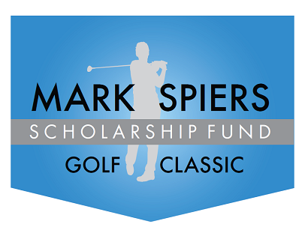
Mark “Mr. Lucky” Spiers
11th Annual Black Friday Golf Outing
A family and friends’ tradition for over 40 years now making it more memorable!
Friday, November 28, 2025
Seaview Golf Club
401 S New York Rd, Galloway, NJ 08205

Registration 9:00am * Shot Gun 10:00 am
Event Details:
GOLFERS: $125 per person includes greens, cart and reception.
Register at www.markspiersfoundation.org Paypal and Credit Card payments now available
SPONSORS: Hole Sponsorships: $150 (logo signage included)
Make checks payable to: Mark Spiers Scholarship Fund and mail to 11 Edgewood Dr. Somers Point NJ 08244
DONATIONS: Payable to the Mark Spiers Scholarship Fund, 11 Edgewood Ave, Somers Point, NJ 08244
Golf Registration
Hole Sponsor
After Party
Donation
EIN #21-0720943
ABOUT: The Mark Spiers Scholarship Fund was established in 2015 by the family of Mark Spiers to honor the memory of their husband and father, who died of GBM brain cancer at the age of 57. Mark was a dedicated husband and father who worked hard and believed in giving his two sons a quality education. In turn, the family would like to support his objective by providing assistance to reward students who are hard-working, caring, respectful, and a team player.

